Assignment No. 7

**Title:-** Object Oriented Modelling (UML Diagram)

**Theory**:-

1. **State Diagram**

Logged In

Browsing Course

Enrolled in course

Go to the Course

Log out

1. **Structural Diagram**

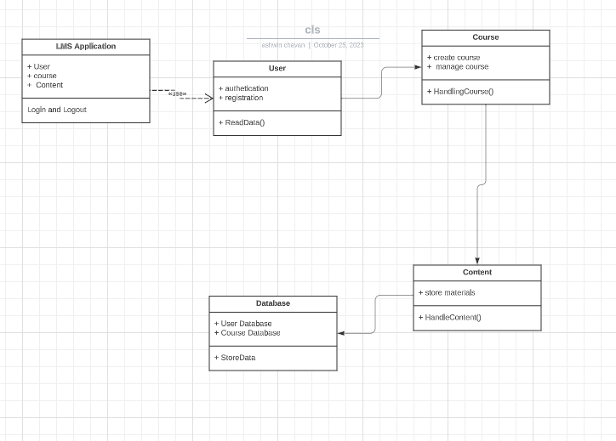

1. **Behavioral Diagram**

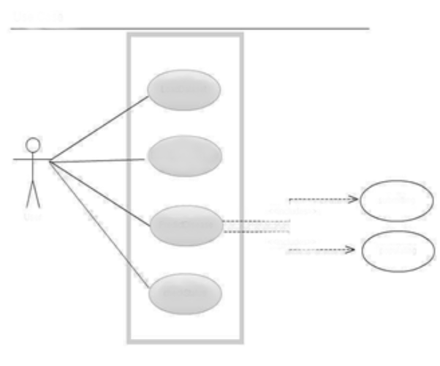

Browse Course

Authentication

Enroll Course

Learn

<<include>>

<<include>>

submitting

populating

User

1. **Architecture diagram**

Frontend

Backend

Analysis

Third Party Service

Authentication Server

Application Server

Load Balance

Registration

Authentication

Database

CDN

User

1. **Architecture diagram**
2. **Architecture diagram**
3. **Architecture diagram**
4. **Architecture diagram**
5. **Architecture diagram**
6. **Architecture diagram**